Business Requirement Document (BRD)
Project Name: Vexa – AI-Powered Knowledge Hub
Version: 1.0
Date: August 21, 2025
Status: Draft for Review
Prepared For: VEXA
Prepared By: Arpreet Mahala
Initial Draft for Stakeholder Review
1. Executive Summary
In the modern information economy, knowledge is the most valuable asset for students, professionals, and organizations. However, this asset is often trapped—scattered across disparate apps, buried in lengthy documents, and rendered inaccessible by inefficient tools. This leads to significant productivity loss, decision-making delays, and collective organizational amnesia.
Vexa is proposed as the definitive solution: an intelligent, AI-native knowledge hub designed to conquer information overload. Vexa moves beyond simple storage by understanding, synthesizing, and connecting information. It acts not just as a repository, but as an active partner in learning and productivity. By centralizing knowledge and leveraging advanced AI for summarization and semantic search, Vexa will transform chaotic data into a structured, actionable, and personalized knowledge ecosystem, ultimately saving users time and unlocking deeper insights.
This document outlines the business needs, objectives, target market, core features, and success criteria for the Vexa platform.

2. Project Overview
2.1. Problem Statement: Individuals and teams lack a unified, intelligent system to effectively capture, organize, distill, and retrieve their growing volume of digital knowledge, leading to inefficiency, duplicated effort, and missed opportunities.
2.2. Project Vision: To create the world's most intuitive and powerful AI-powered knowledge platform, making personalized knowledge management and accelerated learning accessible to everyone.
2.3. Project Scope (In Scope for MVP):
A web application and responsive mobile experience.
Individual user accounts with private knowledge bases.
Core features: Smart Notes, Document Upload (PDF, DOCX, TXT), AI Summarization, Semantic Search, Quick Capture, and basic organization via Folders/Tags.
2.4. Out of Scope (Post-MVP):
Advanced team collaboration features (permissions, shared workspaces).
Real-time collaborative editing.
Advanced AI features like trend analysis or knowledge graph visualization.
Native desktop applications (Windows/macOS).
Integration marketplace with third-party apps (e.g., Slack, Google Drive).

3. Stakeholder Identification

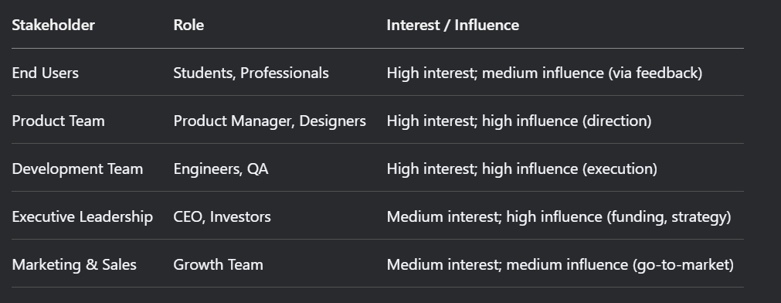

4. Business Goals & Objectives

Goal | Objective | How We Measure (KPI)
Centralize Knowledge | Become the primary knowledge repository for our users. | >60% of active users upload at least one document and create five notes per week.
Enhance Productivity | Significantly reduce the time users spend managing and finding information. | User-reported time savings of >5 hours per week in post-onboarding surveys.
Drive User Adoption | Achieve strong market penetration within target segments. | 10,000 registered users within 6 months of public launch.
Ensure User Satisfaction | Deliver a seamless and valuable user experience that fosters loyalty. | A Net Promoter Score (NPS) of +30 or higher within the first year.
Establish Market Fit | Validate that Vexa solves a critical pain point for a specific audience. | Monthly Active User (MAU) retention rate of >40% after 3 months.

- Target Audience & User Profiles
5.1. Persona: "The Researcher" (Academic)
Name: Dr. Anya Sharma
Bio: A PhD candidate in Neuroscience. She juggles dozens of research papers, lab notes, and article clippings daily.
Frustrations: Wastes hours re-reading papers to find a specific methodology. Notes are scattered between physical notebooks, Evernote, and Zotero. Struggles to synthesize information from multiple sources.
Goals: Wants to quickly extract key findings from papers, connect ideas across research, and have a search that understands scientific concepts.
5.2. Persona: "The Strategist" (Professional)
Name: Mark Chen
Bio: A management consultant who consumes vast amounts of data in the form of reports, client meetings, and market analyses.
Frustrations: Cannot quickly find a specific insight from a past project report. spends the first hour of his day skimming through lengthy industry reports. Team knowledge is siloed.
Goals: Needs instant summaries of long documents, a flawless search to pull up past recommendations, and a way to capture insights from client calls on the fly.

6. High-Level Functional Requirements (MVP Scope)

Feature Category | Description & User Benefit
FR1: User Management | Users can securely register, log in, and manage their profile. Their data is private and encrypted at rest.
FR2: Smart Note-Taking | A clean, responsive editor for creating and formatting notes. Notes are automatically saved and synced across the user's devices.
FR3: Document Management | Users can upload common file types (PDF, DOCX, TXT). The system stores them and displays a clean, organized list in the user's library.
FR4: AI-Powered Summarization | With one click, users can generate a concise, well-structured summary of any uploaded document or long note, highlighting key points and action items.
FR5: Semantic Search | A single search bar that allows users to search their entire knowledge base using natural language queries (e.g., "Find notes about Q3 marketing strategy") instead of just keywords.
FR6: Quick Capture | A simple, always-accessible widget (on web and mobile) that allows users to instantly jot down a thought or idea without opening the full app.
FR7: Basic Organization | Users can create folders and add tags to notes and documents to organize content according to their own mental models.

- Non-Functional Requirements

Requirement | Description
Usability | The interface must be intuitive enough for a non-technical user to become proficient within 15 minutes of first use.
Performance | Search results must be returned in under 2 seconds. Document upload and processing should typically take less than 10 seconds per page.
Availability | The application must maintain 99.5% uptime. Scheduled maintenance will be communicated 48 hours in advance.
Security | All user data must be encrypted in transit (TLS 1.2+) and at rest (AES-256). Authentication will be robust with strong password policies.
Scalability | The architecture must support a ramp-up from 1,000 to 100,000 users without a fundamental redesign of the core system.
Compatibility | The web app must work seamlessly on the latest versions of Chrome, Safari, Firefox, and Edge. The mobile experience must be fully responsive on iOS and Android.

- Success Metrics & Key Performance Indicators (KPIs)
User Growth:
Sign-ups: Number of new registered accounts per week.
Activation Rate: % of new users who complete a key "Aha!" moment (e.g., create a note, upload a doc, and run a search) within first 24 hours.
Engagement:
Weekly Active Users (WAU) / Monthly Active Users (MAU): Measure of stickiness.
Feature Adoption: % of MAU using AI summarization and semantic search each month.

Retention:
Day 7 Retention: % of users still active one week after sign-up.
Month 1 Retention: % of users still active one month after sign-up.

Business:
Net Promoter Score (NPS): Measure of user satisfaction and likelihood to recommend.
9. Assumptions & Constraints
9.1. Assumptions:
Users have a reliable internet connection for core functionality.
The cost of AI inference (e.g., summarization, semantic search) will decrease over time or can be managed profitably within a freemium model.
Target users are frustrated enough with current solutions to try a new platform.
9.2. Constraints:
Budget: Development must adhere to the approved initial funding round.
Time: MVP must be launched to a closed beta group within 6 months.
Technical: Initial development will focus on a web-first application, with mobile responsiveness being a key constraint.

10. Risks & Mitigation Strategies

Risk | Probability | Impact | Mitigation Strategy
User reluctance to switch | High | High | Focus on a seamless import tool from competitors (e.g., Evernote, Notion). Offer a vastly superior core experience (search/summarization) to justify the switch.
AI features underperform | Medium | High | Implement rigorous QA and user testing for AI outputs. Start with a narrow, well-defined scope for summarization and expand based on performance.
Data privacy concerns | High | High | Be transparent about data usage (opt-in for training). Invest in robust security and obtain SOC 2 compliance as soon as feasible. Provide clear, simple privacy policies.
Market competition | High | Medium | Differentiate on simplicity and powerful AI, not just features. Target a specific user persona (e.g., Researchers) first to dominate a niche.

- Glossary of Terms
AI Summarization: The use of artificial intelligence (like a Large Language Model) to read a document and generate a shorter version that captures the main points.
Semantic Search: A search technology that understands the intent and contextual meaning behind a search query, not just matching keywords.
MVP (Minimum Viable Product): The most basic version of a product that can be released to early users to validate the core idea and gather feedback.
KPI (Key Performance Indicator): A measurable value that demonstrates how effectively a company is achieving key business objectives.

12. Approval
This Business Requirements Document has been reviewed and approved by the following stakeholders:
Approved By:
Name: [Stakeholder Name]
Title: [Stakeholder Title]
Date:
Name: [Stakeholder Name]
Title: [Stakeholder Title]
Date:

